

**ME4027 COMPUTATIONAL FLUID DYNAMICS**

**COURSE PROJECT**

**MONSOON 2023-24**

**ANSYS FLUENT PROJECT**

**Submitted byTHANVIR DIOUF S B201120MES7 ME03**

**PROBLEM STATEMENT**

Consider two horizontal plates separated by a distance of 20 mm. The length of the plates is 500 mm each. Water is flowing in between them at a velocity of 5 m/s. Consider the following two cases:

a) When the two plates are stationary,

b) When the top plate is given a horizontal velocity of 5 m/s.

Find the velocity distribution at 𝑥 = 175 mm. Find the 𝑦 −distance from the bottom plate where the velocity is maximum at that location.

Compare the results of (a) and (b).

**INITIAL BOUNDARY CONDITIONS**

* Inlet pressure is zero
* Outlet pressure is zero
* Temperature is uniform
* Bottom plate is fixed
* Water density is 997 kg/m3
* Water viscosity is 0.00089 Pa s
* Top plate is:

1. Fixed in case 1
2. Has 5 m/s velocity in x-direction in case 2

**GEOMETRY CREATION AND MESHING STEPS**

Made the geometry in Ansys 2023 students edition using the design modeler.

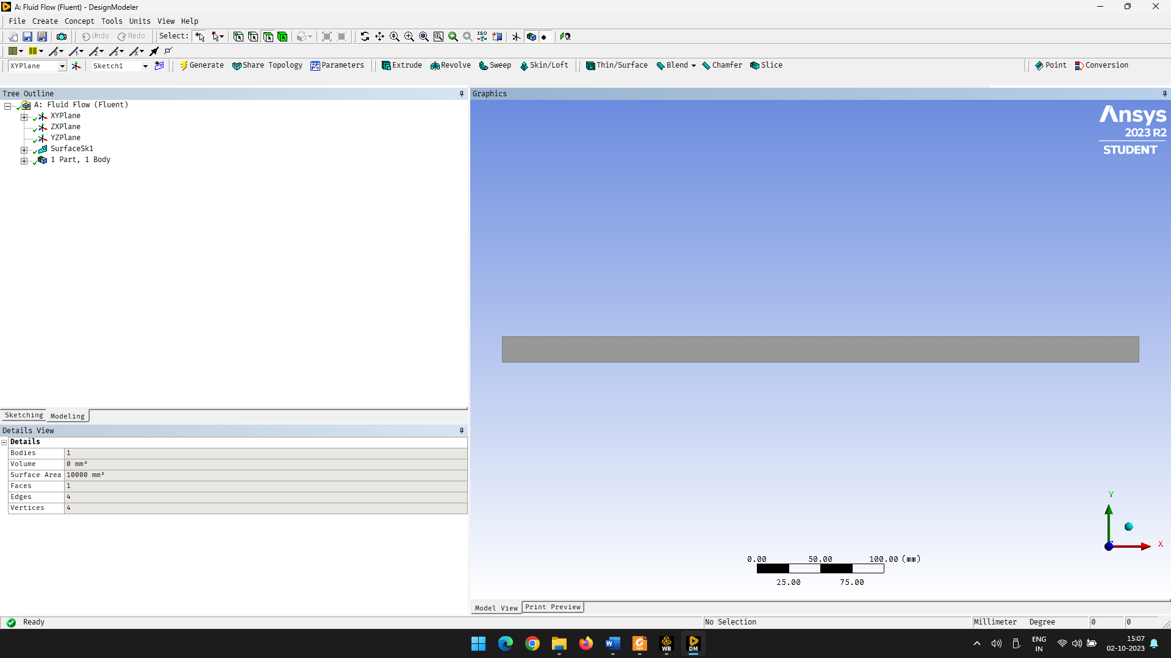

Dimensions are 500mm x 20mm.

Meshing is also done in Ansys.

Element size is 0.5 mm.

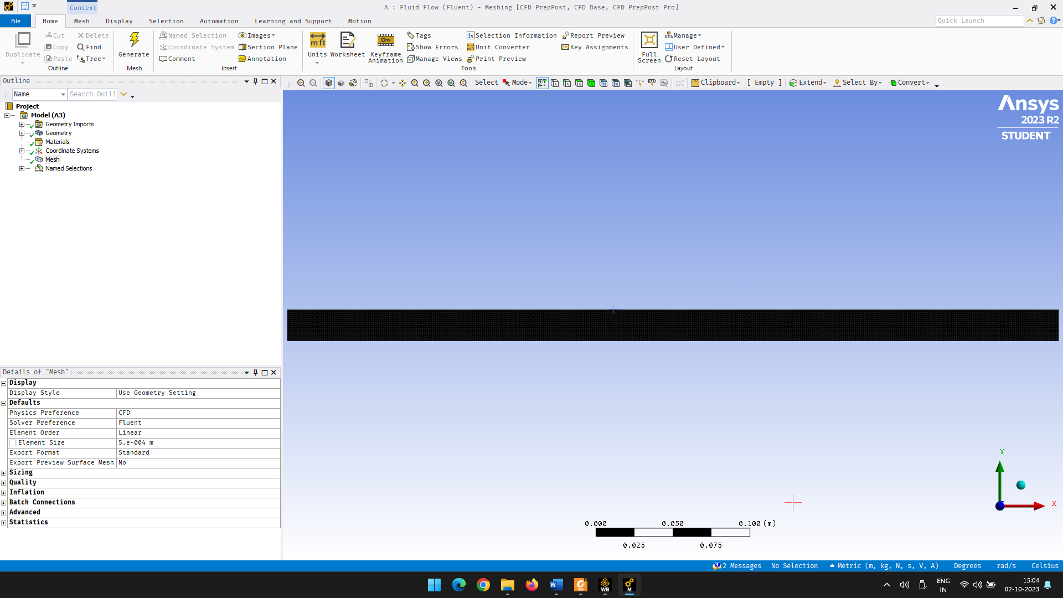

Magnified view

After meshing

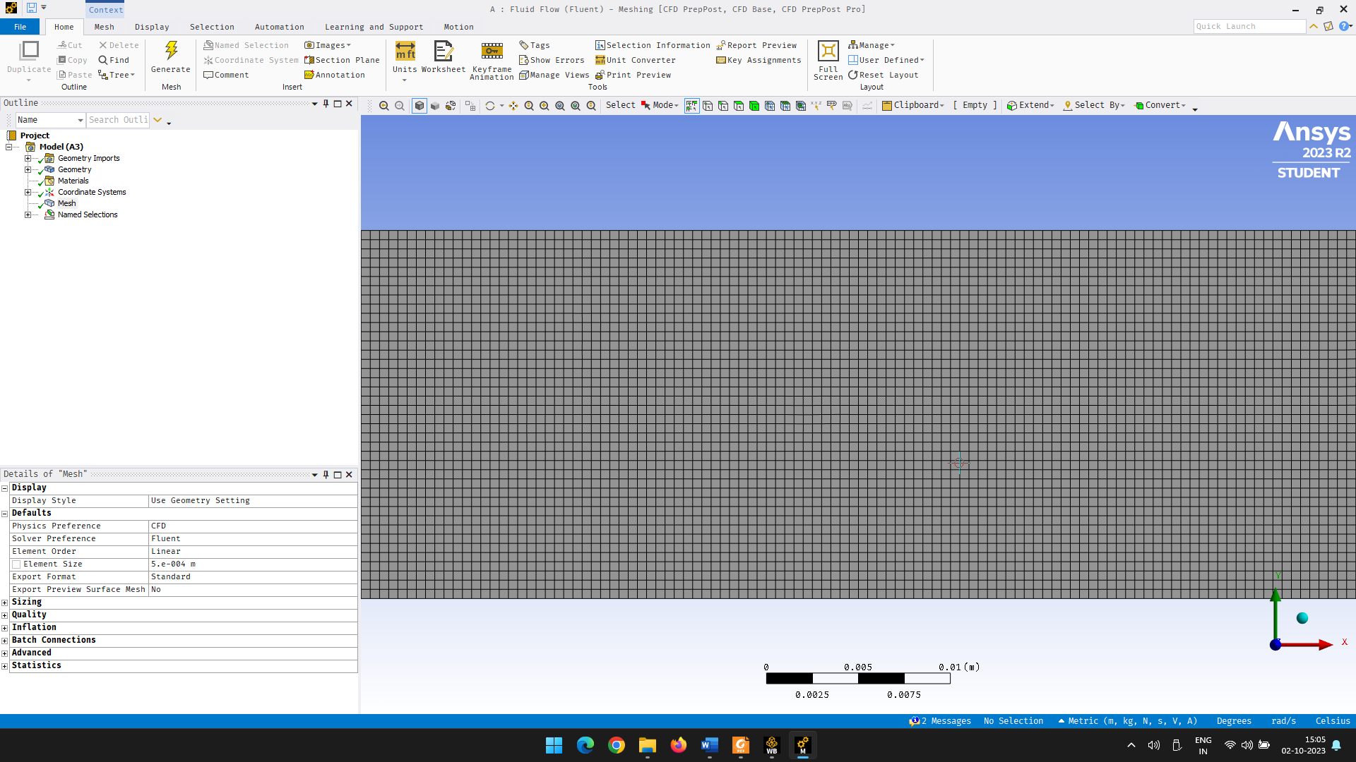

**PROBLEM SETUP**

* Start Ansys Workbench and load Fluent. Click on Geometry and open using Design Modeler.
* Draw a rectangle on the XY plane of dimension 500mm x 20mm.
* Now close the design modeler and edit the mesh. Set the element size to 0.5 mm and click on generate. Then name the sides of the rectangle (inlet, outlet, upper_wall and lower_wall). Click generate and exit mesh editor.
* Open setup and edit the material and set density and viscosity to that of water.
* Set the boundary conditions. Set inlet and outlet pressure as 0. In second case set upper_wall velocity to 5 m/s.
* Right-click on Initialization and click initialize. Then run calculations. Set number of iterations to some number. I set it to 1000. Since this is a simple calculation it happens under 2 minutes.
* Double click on XY Plot under Results. Create a new line at x=175mm and then plot the Y position vs x-velocity graph.
* Click on results and the generate the contour plots, vector plots, stream lines, path lines and profile.

**RESIDUAL HISTORY**

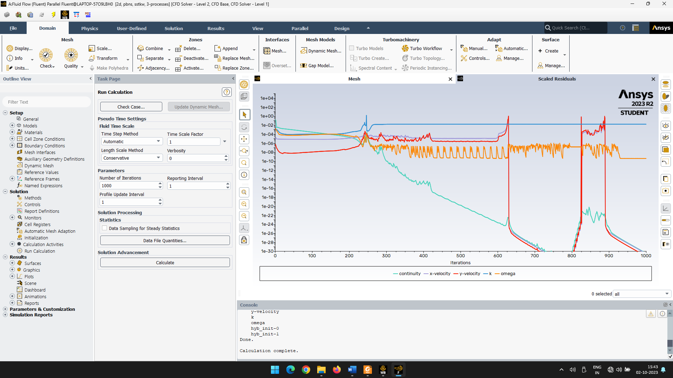

**POST PROCESSING AND RESULTS**

Contour plots:

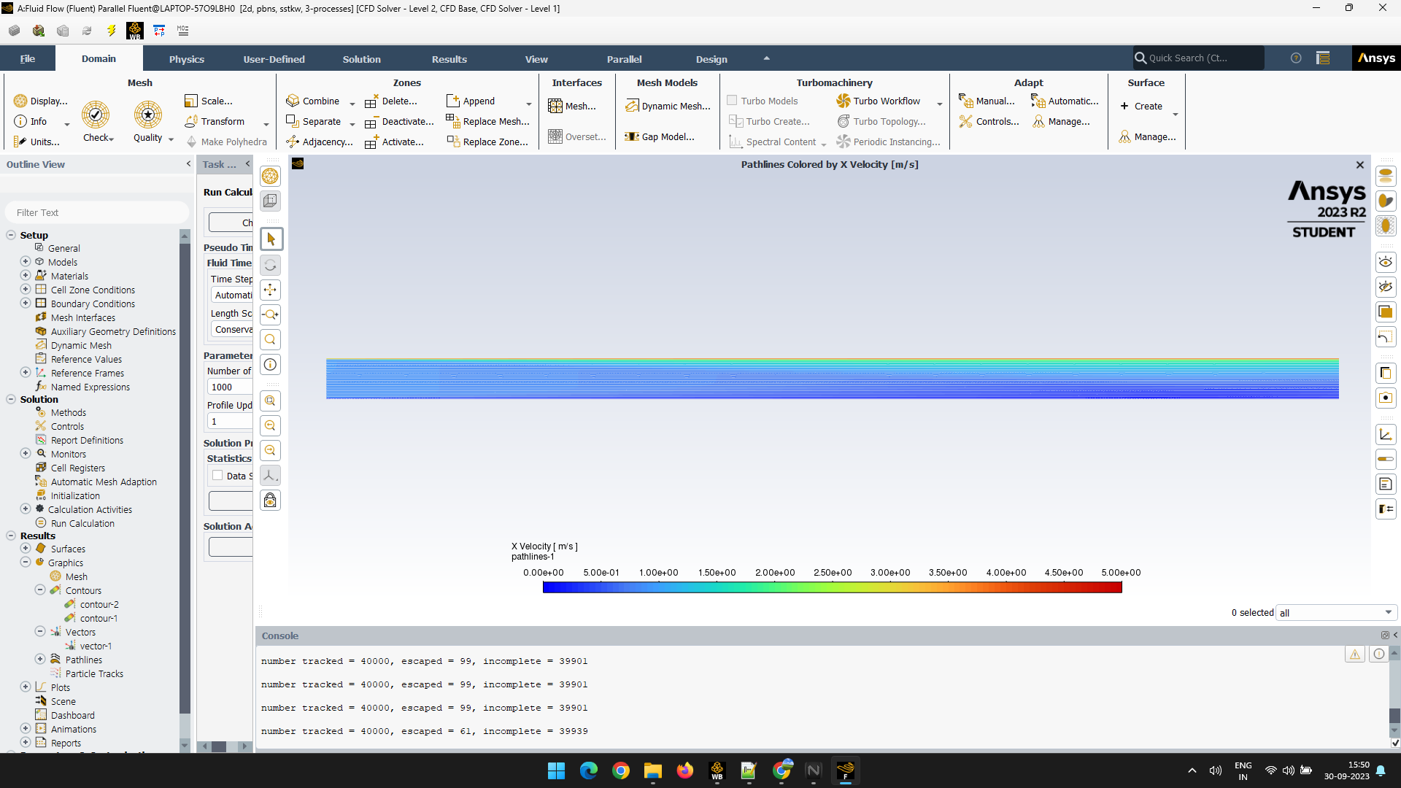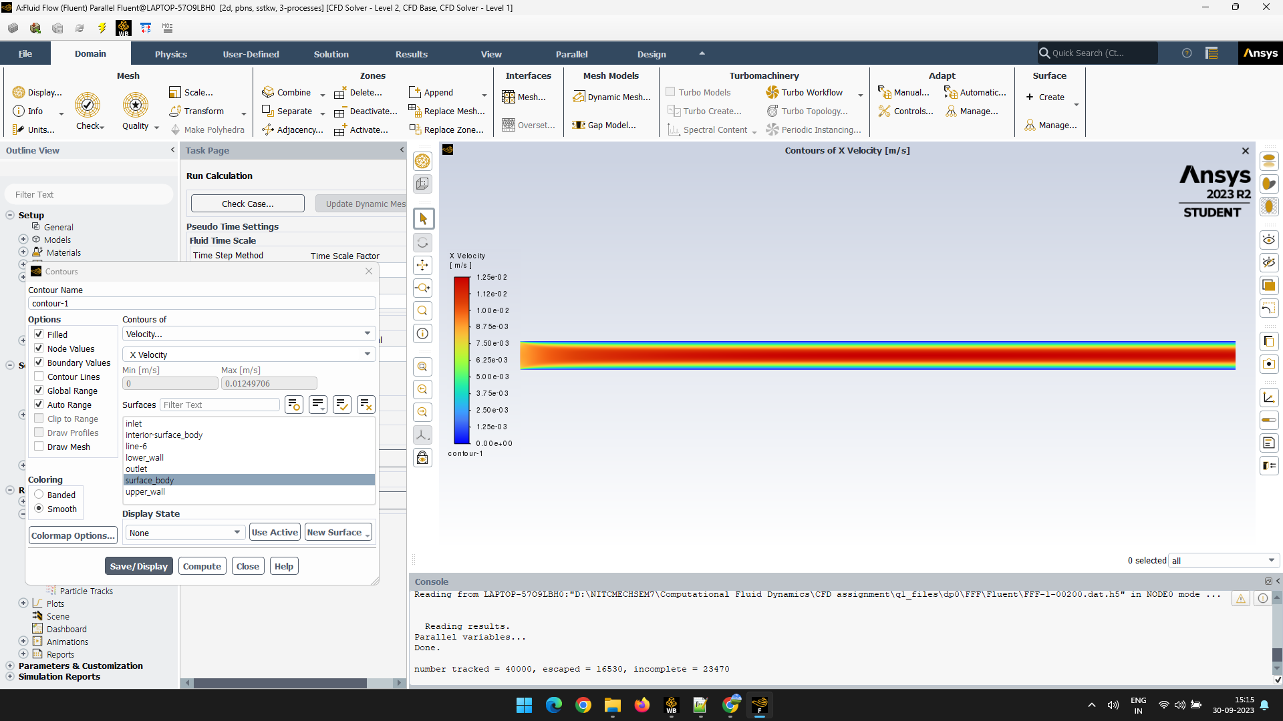

Case 2

Case 1

Pathlines:

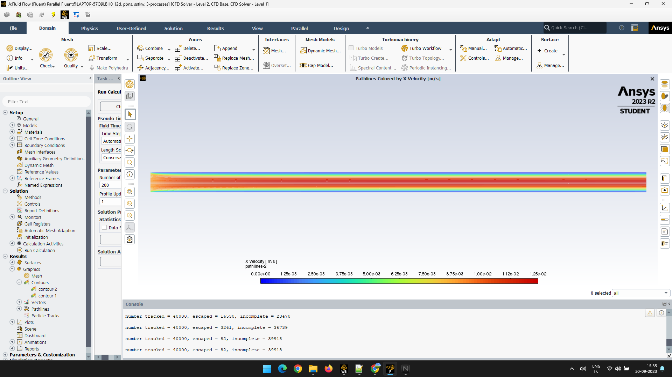

Case1



Case 2

Plotlines:

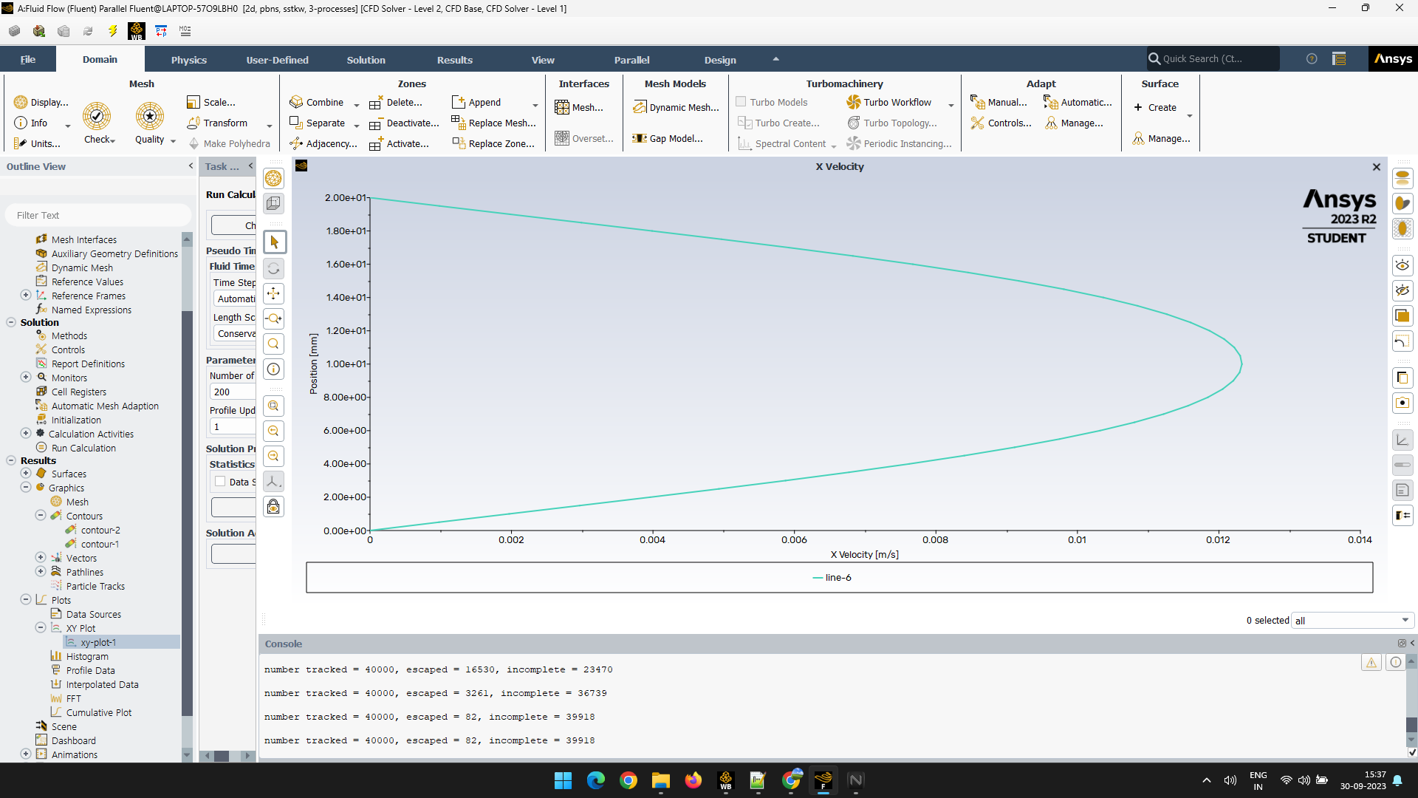

Case 1

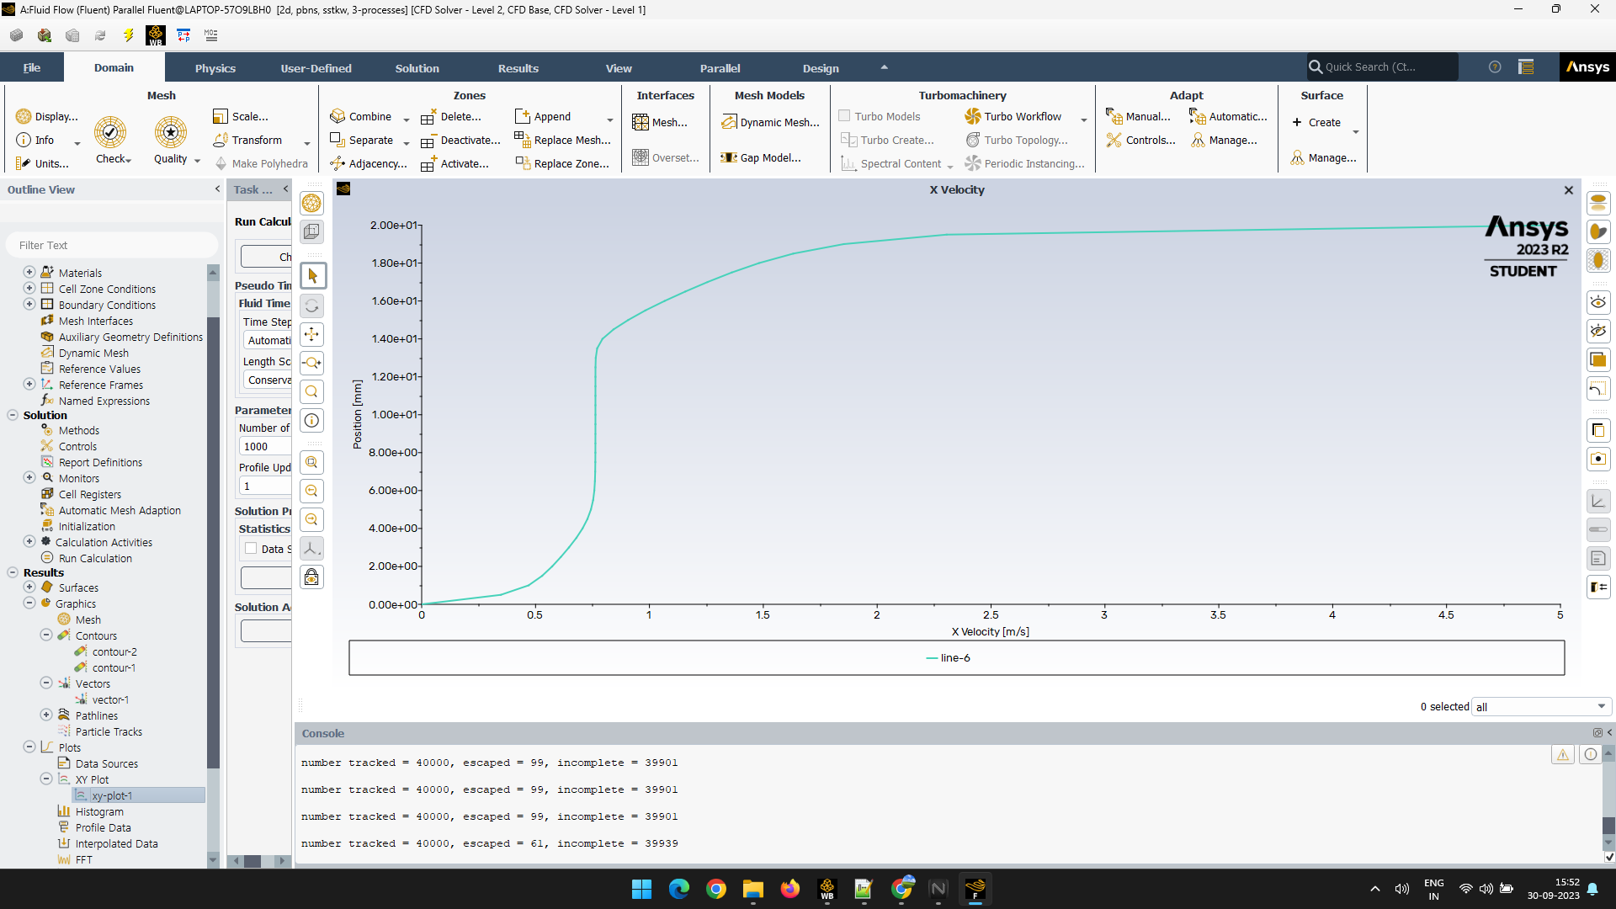

Case 2

Streamlines:

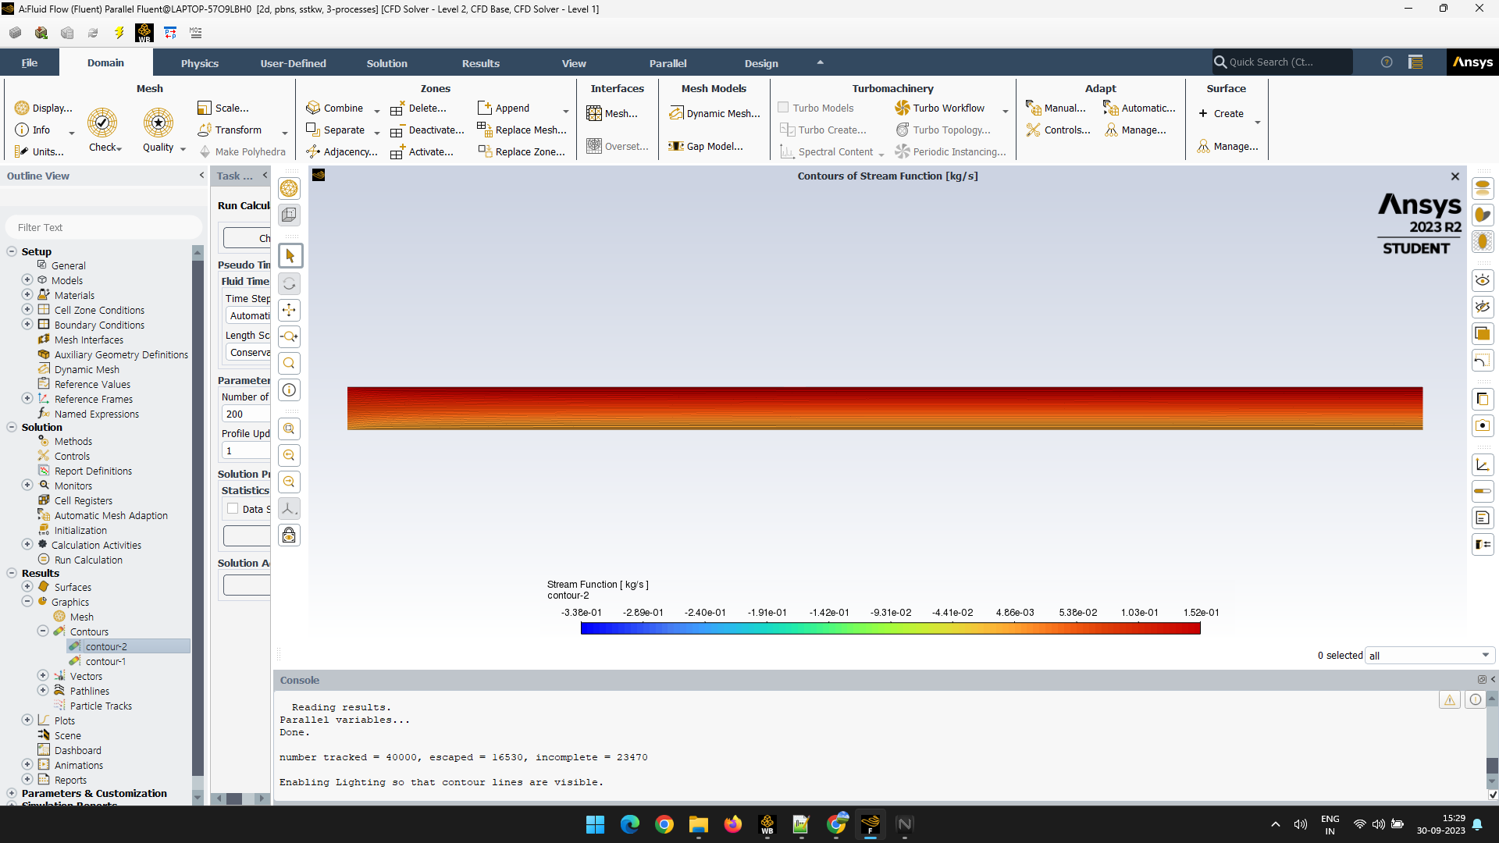

Case 1

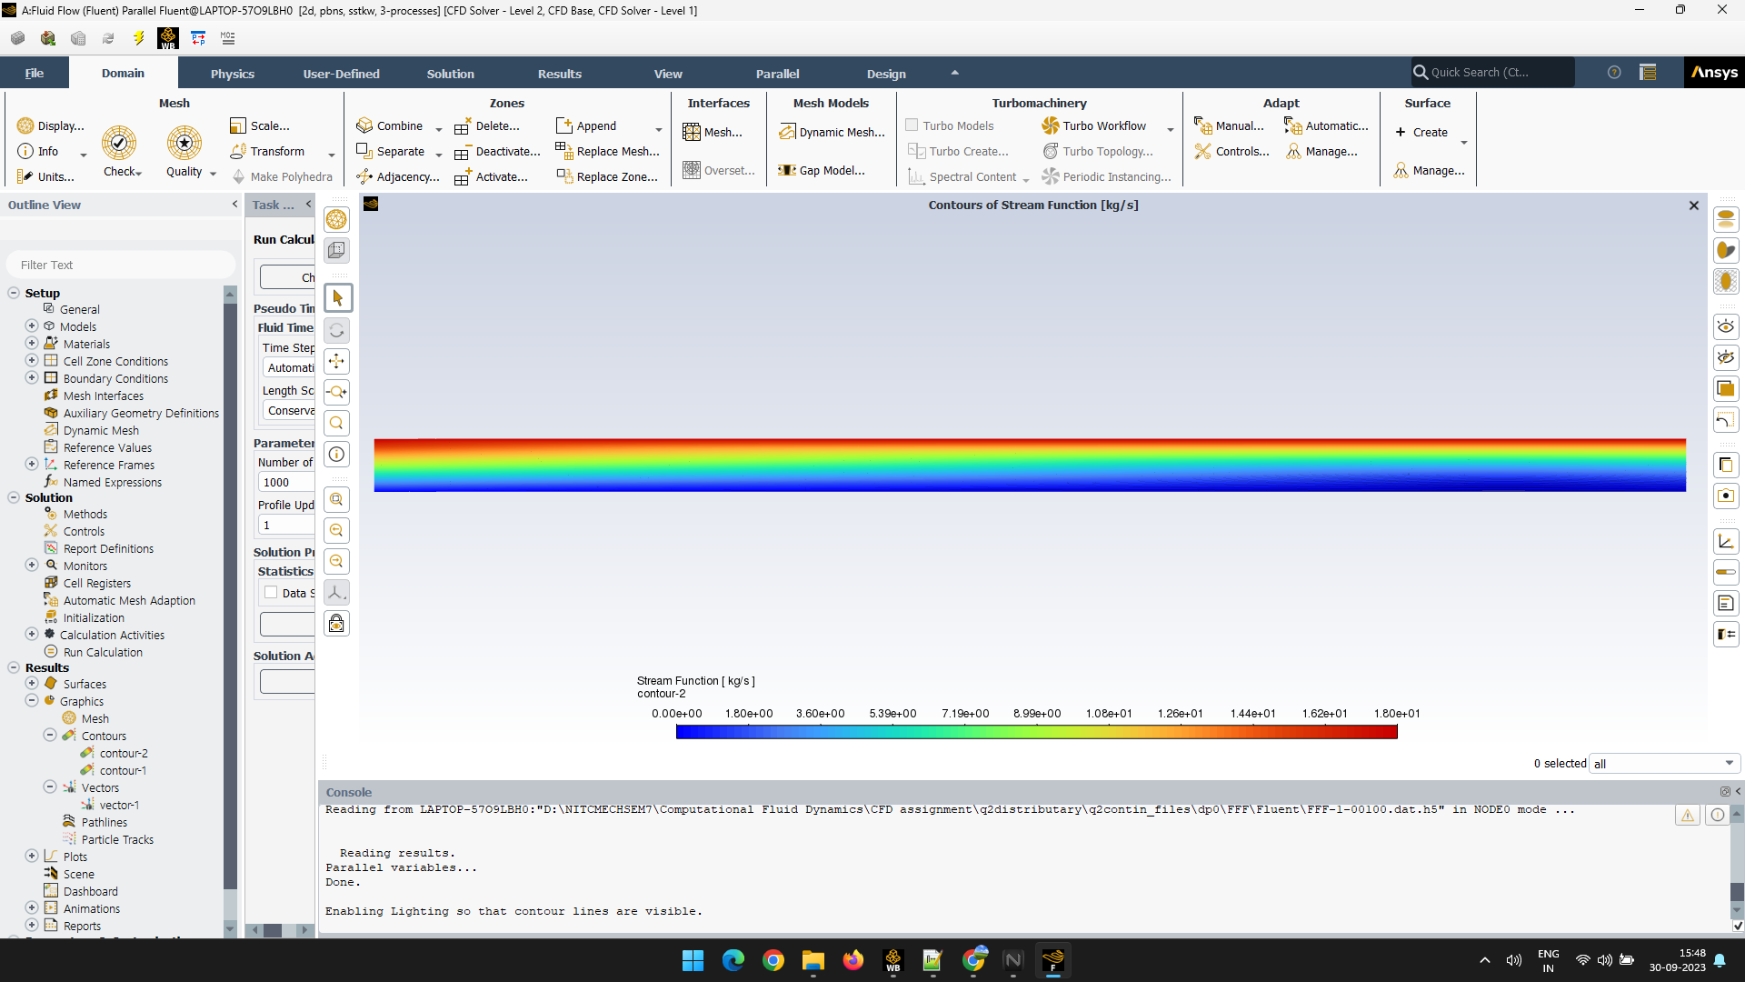

Case 2

Vector Plots:

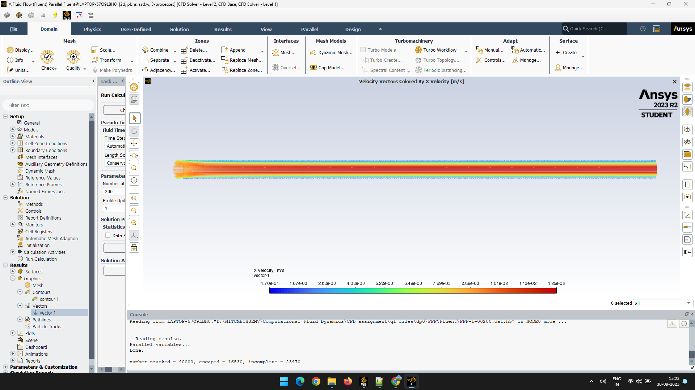

Case 1

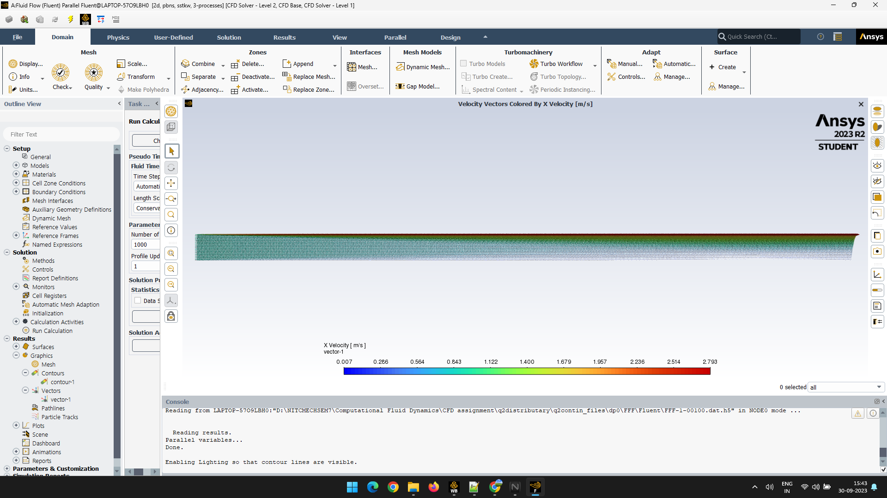

Case 2

**CONCLUSION**

In this project, we have conducted a study about the velocity distribution of water flowing between 2 plates. The simulation results are the same as the expected output aligning with our knowledge of 2-Dimensional fluid flow. This study is important as the data can be used for situations where we use water as a lubricant between 2 flat surfaces.